LEXINGTON Human Sofa

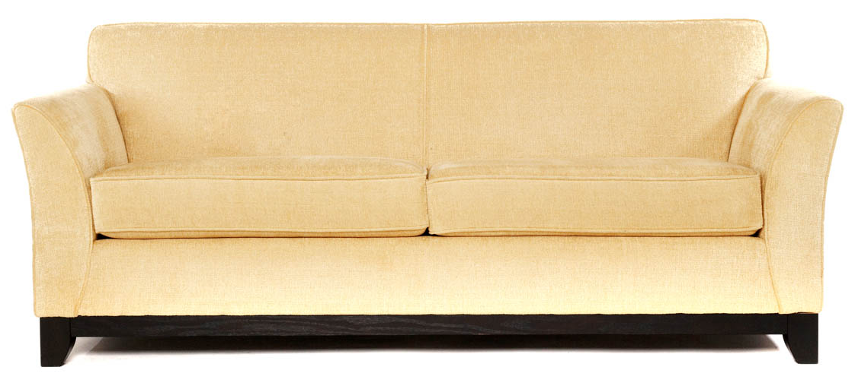

|  |
| --- |
| **DESCRIPTION** |
| Human Sofa produced by LEXINGTON Sofa, presents a sleek, High back design that is both Supporting and very comfortable. The extra-long back relaxes the spinal cord extra long legs on bottom provide stability for the sofa. The leather use in this sofa is made from condensation of tetra redox formation oxides which makes it perfect for relaxation. The leather itself acts as a cushion which makes it perfect without having any grand stability. |

|  |  |  |
| --- | --- | --- |
| **Price** | **1300$** | |
| **Dimensions** | **H** x **W** x **L** | **36in x 33in x 65in** |
| **Features** | **The Sofa is build for two but four people can sit at once because of its tetra collision it tends to be very strong.** | |
| **Finished** | **Tetra Collided Skin** | |
| **Available in** | **Peach Only** | |